UNIVERSITY OF ARKANSAS LECTURE ON SYSTEMS ENGINEERING
Emerging Attributes, Utilizing Systems Analysis, Simple and Comprehensive Examples, Portfolio Manifestations, Summaries and Recommendations
Wolter J. Fabrycky, Lawrence Professor Emeritus at Virginia Tech
Chairman, Academic Applications International, Inc.

SECTION I – SE: EMERGING ACADEMIC AND PROFESSIONAL ATTRIBUTES

From its modest beginnings more than a half-century ago, Systems Engineering is now gaining international recognition as an effective technologically based interdisciplinary process for bringing human-made systems into being, and for improving systems already in being.¹ Certain desirable academic and professional attributes are coming into clear view. Others require further study, development, testing, and implementation.
Section I summarizes the heritage from which Systems Engineering entered the 21st century. Several emerging attributes of Systems Engineering education and professional practice are addressed. These include the necessary but not sufficient academic and professional activities of technical societies, degree programs and program accreditation, certification and licensing, knowledge generation and publications, recognition and honors, and considerations regarding maturity. Attention is directed to those attributes that should be developed further to enable Systems Engineering to serve society well in this century.²

A. Systems Engineering Defined and Described

To this day, there is no commonly accepted definition of Systems Engineering (SE) in the literature.³ Almost a half-century ago, Hendrick W. Bode, writing on “The Systems Approach” in Applied Science-Technological Progress, said that “It seems natural to begin the discussion with an immediate formal definition of Systems Engineering. However, Systems Engineering is an amorphous, slippery subject that does not lend itself to such formal, didactic treatment. One does much better with a broader, more loose-jointed approach. Some writers have, in fact, sidestepped the issue by saying that Systems Engineering is what systems engineers do.” ⁴
Systems Engineering Defined. The definition of Systems Engineering and the systems approach is usually based on the background and experience of the individual or performing organization. The variations are evident from the following published definitions, with sources noted:
- International Council on Systems Engineering: “An interdisciplinary approach and means to enable the realization of successful systems.” ⁵
- Electronic Industries Alliance: “An interdisciplinary approach encompassing the entire technical effort to evolve into and verify an integrated and life-cycle balanced set of system people, product, and process solutions that satisfy customer needs. Systems Engineering encompasses (a) the technical efforts related to the development, manufacturing, verification, deployment, operations, support, disposal of, and user training for, system products and processes; (b) the definition and management of the system configuration; (c) the translation of the system definition into work breakdown structures; and (d) development of information for management decision making.” ⁶
- Defense Systems Management College: “The application of scientific and engineering efforts to (a) transform an operational need into a description of system performance parameters and a system configuration through the use of an iterative process of definition, synthesis, analysis, design, test, and evaluation; (b) integrate related technical parameters and ensure compatibility of all physical, functional, and program interfaces in a manner that optimizes the total system definition and design; and (c) integrate reliability, maintainability, safety, survivability, human engineering, and other such factors into the total engineering effort to meet cost, schedule, supportability, and technical performance objectives.” ⁷
- Institute of Electrical and Electronics Engineers: “An interdisciplinary collaborative approach to derive, evolve, and verify a life-cycle balanced system solution which satisfies customer expectations and meets public acceptability.”^{.8}
- U.S. Department of Defense: “An approach to translate operational needs and requirements into operationally suitable blocks of systems. The approach shall consist of a top-down, iterative process of requirements analysis, functional analysis and allocation, design synthesis and verification, and system analysis and control. Systems Engineering shall permeate design, manufacturing, test and evaluation, and support of the product. Systems Engineering principles shall influence the balance between performance, risk, cost, and schedule.”^{.9}

Although the five definitions above vary, there are many common threads. Basically, Systems Engineering (SE) is good engineering with special areas of emphasis. Some of these are: a top-down approach; a life-cycle orientation; a more complete early effort regarding the definition of system functions, relating functions through requirements to design criteria, followed by an effort to ensure the effectiveness of early decision making within the design process on downstream outcomes; and an interdisciplinary or team approach applied throughout the design and development process.
Systems Engineering Described. Systems Engineering may be described as a technologically based interdisciplinary process for bringing human-made systems and their products (technical entities) into being. While the main focus is nominally on the entities themselves, Systems Engineering offers an improved strategy. Systems Engineering is inherently oriented toward “thinking about the end before the beginning” and concentrates on what the entities are intended to do before determining what the entities are, with form following function.³
Instead of offering systems or system elements and products per se, Systems Engineering focuses on designing, delivering, and sustaining functionality, a capability, or a solution. This strategic thinking is now being considered by forward-looking enterprises in both the private and public sectors. It is applicable to most types of technical systems, encompassing the human activity domains of communication, construction, defense, education, healthcare, manufacturing, transportation, and many others. All system types are service systems, with service provided by the system product.
Systems Engineering is not a traditional engineering discipline in the same sense as civil engineering, electrical engineering, industrial engineering, mechanical engineering, producibility engineering, reliability engineering, or any of the other engineering domains and specialties. It should not be organized in a similar manner, nor does the implementation of Systems Engineering or its methods require extensive organizational resources. But, for best results, a well-planned and disciplined approach should be adopted and followed.
The Systems Engineering process involves the use of appropriate technologies and management principles in a synergetic manner. Its application requires synthesis and a focus on process, along with a new thought process to meet 21st Century challenges.^{10,11}
B. Systems Engineering Professional Societies
In response to the growing interest in academic aspects of Systems Engineering, the American Society for Engineering Education (ASEE) established a Systems Engineering Constituent Committee (SECC) in 2002. SECC is now a full Division (SED) with membership exceeding 150, indicating considerable interest in SE by educators from most of the engineering technical societies.

Among engineering technical societies, IEEE organized a Systems Council and the NDIA established a division for SE. Some engineering societies have added SE sections or divisions. The American Society for Agricultural Engineers, now the American Society of Agricultural and Biological Engineers (ASABE), has encouraged inclusion of the phrase ‘biological systems’ in its cognizant degree programs. Then there is the often discussed change of name of the Institute of Industrial Engineers (IIE) to the Institute of Industrial and Systems Engineers (IISE).

There is one professional society that focuses exclusively on SE. It is the International Council on Systems Engineering (INCOSE, www.incose.org), founded in 1990 as a result of concerns about a shortage of qualified individuals prepared to think in terms of the total system. General Dynamics sponsored the first meeting in San Diego, Boeing hosted the next meeting in Seattle, and IBM facilitated an academic workshop in Northern Virginia. Among the long list of issues identified, were four that are the concern of academia:
- Lack of clear requirements for Systems Engineering degree programs,
- Few Systems Engineering graduates,
- Lack of textbooks on Systems Engineering, and
- Few accredited Systems Engineering programs.

INCOSE is an international technical council formed to develop, nurture, and enhance the multidisciplinary approach of transdisciplinary Systems Engineering as a means to enable the realization of successful systems. INCOSE has strong and enduring ties with industry, academia, and government to support two high level objectives:
1. To gain further recognition by industry, government, academia, and its sister professional societies of the importance of Systems Engineering, and
2. To achieve wide acceptance of INCOSE as a leading Systems Engineering society; and position INCOSE as a unifying force across engineering communities and specialties.
The International Council on Systems Engineering is now well established and is rapidly expanding both domestically and internationally. Enabled by more than 80 chapters worldwide and guided by a Corporate Advisory Board of almost 100, INCOSE is continuing to:
- Provide a focal point for dissemination of Systems Engineering knowledge,
- Promote collaboration in Systems Engineering education and research,
- Assure professional standards for integrity in the practice of Systems Engineering,
- Improve the professional status of those engaged in the practice of Systems Engineering.
- Improve the professional status of those engaged in the practice of Systems Engineering, and
6. Encourage governmental and industrial support for research and educational programs that will improve the Systems Engineering process and its practice.

C. Systems Engineering Degree Programs

A comprehensive study of Systems Engineering degree programs in the United States was presented at INCOSE 2005, based on 2004 data.¹² That study provided a descriptive benchmark of programs encompassing academic content, administrative structure, accreditation status, and related topics. It was determined that, in 2004, there were 75 academic institutions offering 130 undergraduate and graduate degree programs in Systems Engineering.

Now, these data are used herein for the same purpose. It is determined that at least 80 institutions in the US offer more than 165 undergraduate and graduate degree programs in Systems Engineering. This is a significant increase, mostly at the graduate level.
To produce results comparable with the 2005 study, SE degree programs are again partitioned into two broad categories: Systems Centric Systems Engineering Programs and Domain Centric Systems Engineering Programs. The findings are summarized below from data exhibited in two tables. But caution is advised; What’s in a Name?

Systems Centric Systems Engineering (SCSE) Programs. Basic and advanced level programs leading to a bachelors or higher degree in Systems Engineering comprise a distinct category with a discipline-like focus. Included herein are only those degree programs where the concentration is designated Systems Engineering; where SE is the intended major area of study.

There are 37 institutions that offer 56 degree programs in the SCSE category. There was no increase in the number of undergraduate programs, but graduate programs increased by 8 over the five-year study period (2004-09). The count by degree program level is given in Table 1 and are listed immediately following.

Table 1. Systems Centric Systems Engineering (SCSE) Programs

BS MS PhD
Program count 11 + 31 + 14 Total = 56

Degree Programs | Institution
MS, PhD in Systems Engineering | Air Force Institute of Technology
MS, PhD in Systems Engineering | Boston University
BS, MS, PhD in Systems & Control Engineering | Case Western Reserve University
ME in Systems Engineering | Colorado State University
ME in Engineering, Systems Engineering Option | Cornell University
BS, MS, PhD in Systems Engineering | George Mason University
MS, PhD in Systems Engineering | George Washington University
ME in Systems Engineering | Iowa State University
MS in Systems Engineering | Johns Hopkins University
BS, MS in Information & Systems Engineering | Lehigh University
PhD in Engineering Systems | Massachusetts Institute of Technology
MS, PhD in Systems Engineering | Missouri University of Science & Tech
MS in Systems Engineering | Naval Postgraduate School
ME in Systems Engineering | Pennsylvania State University
MS in Information Systems Engineering | Polytechnic University - Farmingdale
ME in Engineering, Systems Engineering Option | Portland State University
ME in Systems Engineering | Rochester Institute of Technology
MS, PhD in Systems Engineering | Southern Methodist University
MS in Systems Engineering | Southern Polytechnic State University
ME, PhD in Systems Engineering | Stevens Institute of Technology
BS in Systems Engineering | United States Air Force Academy
BS in Systems Engineering | United States Military Academy
BS in Systems Engineering | United States Naval Academy
MSE, PhD in Systems Engineering | University of Alabama - Huntsville
BS, MS in Systems Engineering | University of Arizona
BS in Systems Engineering | University of Arkansas - Little Rock
MS in Systems Engineering | University of Houston - Clear Lake
ME in Systems Engineering | University of Idaho
MS in Systems Engineering | University of Maryland
PhD in Information Systems Engineering | University of Michigan
BSE, MSE, PhD in Systems Science & Engineering | University of Pennsylvania
MS in Systems Architecture & Engineering | University of Southern California
MS in Systems Engineering | University of Texas - Arlington
MS in Systems Engineering | University of Texas - San Antonio
BS, MS, PhD in Systems Engineering | University of Virginia
MS in Systems Engineering | Virginia Tech
BS, MS, PhD in Systems Science & Engineering | Washington University

Domain Centric Systems Engineering (DCSE) Programs. Basic and advanced level programs leading to a bachelors or higher degrees with the major designated as X Systems Engineering, Systems and X Engineering, etc. are designated Domain Centric SE. Included in this distinct category are those degree programs naming Systems Engineering within a parent engineering domain.
A continuing desideratum is to integrate Systems Engineering topics into selected courses within the traditional engineering disciplines. Widening the number of disciplines and application areas to which SE may be applied will likely infuse systems thinking within more engineering domains. On the basis of program names alone, there were 48 institutions with 82 DCSE degree programs in 2004. By 2009, 52 institutions (9 of these duplicate institutions in the SCSE category) offer 109 DCSE programs across several engineering domains. These are identified in Table 2 and listed by individual institution and program immediately following.
Table 2. Domain Centric Systems Engineering (DCSE) Programs

 | BS | MS | PhD
SE with Biological Engineering | 18 | 10 | 6 | 34
SE with Computer Engineering | 7 | 5 | 3 | 15
SE with Industrial Engineering | 17 | 17 | 13 | 47
SE with Management Engineering | 1 | 2 | 0 | 3
SE with Manufacturing Engineering | 1 | 8 | 1 | 10
Totals | 44 | 42 | 23 | 109

Institution | Degree Programs
Arizona State University | BS in Computer Systems Engineering
Auburn University | BS in BioSystems Engineering  MS in Manufacturing Systems Engineering  MS, ME, PhD in Industrial & Systems Engineering
Boston University | BS, MS in Computer Systems Engineering
California State University - Northridge | BS in Manufacturing Systems Engineering
Colorado State University - Pueblo | MS in Industrial & Systems Engineering
Florida A&M University | BS in Biological & Agricultural Systems Engineering
Florida International University | BS in Industrial & Systems Engineering
Lehigh University | PhD in Industrial & Systems Engineering
Michigan State University | BS in BioSystems Engineering
New Jersey Institute of Technology | MS in Manufacturing Systems Engineering
North Carolina A&T University | BS in Industrial & Systems Engineering
North Dakota State University | BS, MS in Agricultural & BioSystems Engineering
Northeastern University | MS, PhD in Computer Systems Engineering
Northern Illinois University | BS, MS in Industrial & Systems Engineering
Oakland University | BS, MS, PhD in Industrial & Systems Engineering
Ohio State University | BS, MS, PhD in Industrial & Systems Engineering
Ohio University | BS, MS, PhD in Industrial & Systems Engineering
Oklahoma State University | MS in Industrial & Manufacturing Systems Engineering  BS, MS, PhD in BioSystems Engineering
Purdue University | PhD in Manufacturing & Production Systems Engineering
Rensselaer Polytechnic Institute | BS, MS, PhD in Industrial & Systems Engineering  BS, MS, PhD in Computer & Systems Engineering
San Jose State University | BS, MS, PhD in Industrial & Systems Engineering
South Dakota State University | BS, MS in Agricultural & BioSystems Engineering
Stanford University | MS in Manufacturing Systems Engineering
State University of NY - Binghamton | BS, MS, PhD in Systems & Industrial Engineering
Texas A&M University | BS, MS, PhD in Biological Systems Engineering
Texas Tech University | MS in Manufacturing Systems & Engineering
University of Alabama - Huntsville | BS, MS, PhD in Industrial & Systems Engineering
University of Alaska | BS, MS, PhD in Computer Systems Engineering
University of Arizona | BS in BioSystems Engineering  BS in Computer Systems Engineering  PhD in Systems & Industrial Engineering
University of California - Davis | BS, MS, PhD in Biological Systems Engineering
University of Central Florida | MS in Systems Engineering & Management
University of Florida | BS, MS, PhD in Industrial & Systems Engineering
University of Hawaii at Manoa | BS in BioSystems Engineering
University of Houston | MS in Computer & Systems Engineering
University of Houston – Clear Lake | BS in Computer Systems Engineering
University of Idaho | MS in Biological Systems Engineering
University of Kentucky | BS, MS, PhD in BioSystems Engineering
University of Massachusetts | BS in Computer Systems Engineering
University of Michigan - Dearborn | BSE, MSE in Industrial & Systems Engineering  MSE in Manufacturing Systems Engineering
University of Minnesota | BS in Biosystems & Agricultural Engineering  BE in Bioproducts & BioSystems Engineering
University of Nebraska - Lincoln | BS, MS in Biological Systems Engineering
University of Pittsburgh | MS in Manufacturing Systems Engineering
University of San Diego | BS, MS in Industrial & Systems Engineering
University of South Florida | BS, MSE in Industrial & Management Systems Engineering
University of Southern California | BS, MS, PhD in Industrial & Systems Engineering
University of St. Thomas | MS in Manufacturing Systems Engineering
University of Tennessee | BS in BioSystems Engineering
University of Wisconsin | BS in Biological Systems Engineering
Virginia Tech | BS, MS, PhD in Biological Systems Engineering  BS, MS, PhD in Industrial & Systems Engineering
Washington State University | BS, MS, PhD in Biological Systems Engineering
Wright State University | BS, MS in Industrial & Systems Engineering
Youngstown State University | BE, MS in Industrial & Systems Engineering

In the tables presented above, both the institution and degree program information was obtained from Peterson’s Guide to Programs in Engineering and Applied Science.¹³ Both the ABET web site at www.abet.org and the INCOSE web site at www.incose.org were used. This was augmented by information from other sources, particularly individual institutions. Note that ABET accredited degree programs are indicated in the tables by use of bold face type.
Organization and Administration of SE Programs. Not all Systems Engineering degree programs are administered through the classical departmental structure of the host institution. One must be aware of the administrative and organizational home for a degree program of interest to fully understand its academic context.
Most undergraduate programs are classically organized within academic departments, but at the graduate level the following variants will be found:
- There are instances where an academic administrative unit will be the home for more than one degree program; e.g., Industrial and SE as well as Manufacturing SE. The department name may or may not subsume the names of all degree programs (e.g., Auburn U).
- There are instances where an institution offers both SCSE and DCSE programs; e.g., Systems Engineering (SC), Biological Systems Engineering (DC), and Industrial and Systems Engineering (DC). The DCSE programs are administered within departments whereas the SCSE program is organized in an interdepartmental mode (e.g., VaTech).
- In those instances where an institution offers a SCSE program at the basic and advanced levels, all are usually administered within a department (e.g., UVa). This may also be true for DCSE programs, except that the SE component may not exist at all degree levels.
- An institution may have SE organized and administered within a center that cooperates with engineering domain departments to offer Systems Engineering (or Engineering Systems) degrees through those departments (e.g., MIT).

When considering basic and advanced level programs in the SCSE and DCSE categories, focus will be targeted properly by recognizing that Systems Engineering is broad in nature. It should not be viewed in the same context as the traditional engineering disciplines. This notwithstanding, many domains of engineering are seeking a better topical balance by adopting systems thinking. This is the primary reason for the rapid growth in the number of engineering academic domains adding SE topics and projects.
Over time, infusion of systems thinking into engineering curricula has been formalized in discrete courses, but Systems Engineering means different things to different people. This is especially true for the meaning imparted to degree programs by academic institutions. A degree program designated SE at one institution may not be the same as a degree program with the same designation at another. Accordingly, in considering the attributes of degree programs called Systems Engineering (whether they are SCSE or DCSE) one should go directly to the published curriculum to examine course content. At issue here again is the question of What’s in a Name?
D. Systems Engineering Program Accreditation
The Accreditation Board for Engineering and Technology (ABET) is a federation of societies that accredits academic programs in engineering and related areas of the applied sciences. This is accomplished through four Accreditation Commissions. Unlike bodies that accredit the entire academic institution, ABET focuses on the characteristics of programs and the products of these programs for the purpose of advancing quality.¹⁴ This widespread misunderstanding seems to be intentionally utilized in a few cases.
The mission of ABET is accomplished through the professional engineering societies serving as participating bodies. After a seven year application and approval process, the International Council on Systems Engineering became a participating society in ABET seven years ago, a fourteen-year effort. INCOSE has an opportunity and obligation to advance its interest in the quality of Systems Engineering education. This necessitates supporting the mission of ABET, while at the same time supporting its honors and awards program and other activities focusing on quality first as is promulgated by its cognizant honor society.
Multiple Lead Society Concept. ABET has adopted a Multiple Lead Society (MLS) approach for accrediting degree programs that are of interest to more than one participating society. Systems Engineering is one of the first to utilize this approach, the characteristics of which are:
- The MLS approach applies to SCSE programs, thus encouraging cooperation within SE while avoiding undue competition.
- INCOSE assumes the nominal obligation to accredit SE degree programs (mostly SCSE) upon university request through ABET.
- INCOSE has the opportunity to collaborate with those ABET participating societies that incorporate SE topics in their engineering domains of study (AIAA, ASME, IEEE, IIE, ISA, SAE, SME, and others that may join the MLS cluster for SE).
- Through participating society status, INCOSE has direct involvement within academia for Systems Centric SE, and indirect influence for Domain Centric SE, all administered within the ABET programmatic accreditation enterprise.
- At present, there are no program specific criteria for Systems Engineering. INCOSE has the opportunity to collaborate in the development of criteria for accrediting engineering programs that incorporate SE.

The ABET accreditation opportunity is viewed by INCOSE as critical to the advancement of Systems Engineering in its own right, as well as essential to the infusion of SE thinking within the domain manifestations of SE. INCOSE aspires to lead in the category of Systems Centric SE programs and collaborate with the other professional bodies participating in ABET for Domain Centric SE programs.

Accreditation of SE Programs. ABET leaves it to the institution to choose the degree level at which it will seek program accreditation; that is, to declare whether the ‘first professional' degree for entry into the profession is to be at the basic or the advanced level. However, it is the policy and practice of most academic institutions to submit only undergraduate programs for ABET accreditation. Thus, the opportunity for professional societies to influence graduate programs through ABET is quite limited.

The number of SE programs by category, and the number of ABET accredited programs (noted by bold type), are summarized in Table 3. Refer to Table 1 and Table 2 for specific programs that are accredited, also indicated there in bold type. Up-to-date information regarding ABET programs that are accredited may be found at www.abet.org
Table 3. SE Programs by Category and Degree Level with Accreditation Noted.
SE  Category | Number  BS/BS | Number  MS/MS | Number  PhD/PhD | Number of  Programs | % ABET  Accredited
Systems Centric SE | 11/11 | 31/2 | 14/0 | 56/13 | 21.4%
Domain Centric SE | 44/44 | 42/1 | 23/0 | 109/45 | 41.3%
Totals | 55/55 | 73/3 | 37/0 | 165/58 | 34.5%

Fifty five (55) of the 165 degree programs in Systems Engineering are at the undergraduate level, all ABET accredited. This leaves 110 SE programs at the graduate level, only three of which are ABET accredited (graduate programs in SE outnumber undergraduate programs exactly 2 to 1). Only 57 out of the 165 degree programs in SE are accredited. This is barely more than one-third of all SE programs in the US. This is the basis for the suggestion (in Section V) that the idea of academic program certification at the graduate level be considered.

SE Program Criteria. Criteria for the accreditation of Systems Engineering programs at the basic level are based upon the published General ABET Criteria for those institutions offering programs at this level.¹⁴ Institutions seeking accreditation for the first professional degree in Systems Engineering at the advanced level must meet the published General ABET Criteria for advanced level programs in addition to the basic level criteria. INCOSE fully supports the General ABET Criteria as it applies to basic level and to advanced level accreditation, recognizing that the decision to apply for accreditation review at the basic or the advanced level is to be made by the institution. Participating bodies provide the program specific criteria and institutions choose the accreditation level to be requested.

At present, there are no program specific criteria for Systems Engineering. Thus far, SE programs have been accredited by ABET upon request under a special category. Program criteria unique to Systems Engineering will be developed by the group of participating societies for SE under the Multiple Lead Society Concept (see Section IV). This will be accomplished through the Engineering Accreditation Commission of ABET in due time and approved by the ABET Board when consensus has been reached.
Unlike many bodies that accredit academic institutions, ABET focuses on the characteristics of degree programs and the products of these programs for the purpose of enhancing quality. INCOSE has an opportunity and obligation to advance its interest in the quality of SE education by diligently supporting the mission of ABET. This is occurring through both ABET Board membership (policy) and participation in ABET program reviews (operations).
E. Accreditation is Necessary but Not Sufficient for SE
Returning again to certification, but squarely in the context of academic programs. In contrast to certification of individuals as presented in Section V, academic program certification strives to enhance the assurance that program graduates are uniformly of high quality. By improving the process producing graduates through certification, it is conjectured that the product thereof will be of higher quality and capability.¹⁵

It is argued that Systems Engineering accreditation by ABET is necessary but not sufficient for at least four reasons:

- Nominally, only undergraduate degree programs are offered by academic institutions for ABET accreditation.
- Systems Engineering programs are not increasing in number at the undergraduate level, but are expanding rapidly at the graduate level.
- The influence of ABET is centered principally in the United States, whereas Systems Engineering is steadily expanding worldwide.
- ABET is unlikely to embrace the full potential of SE as promulgated by ASEE-SED, INCOSE, and domain societies interested in SE.

The vision for academic certification is predicated on the proposition that graduate study in Systems Engineering would produce more uniformly effective graduates if programs with certain desirable institutional and programmatic characteristics are recognized. Economically feasible web-based assessment to recognize quality outcomes could be initiated worldwide. Accordingly, certification of superb SE degree programs is being encouraged by some visionaries. As a counterpart to professional certification of individuals, certification of Systems Engineering degree programs within academia may be timely for that important reason.

Program certification is also suggested for engineering degrees with characteristics similar to those of Systems Engineering. These are increasing in number at the graduate level and have come into existence to satisfy voids created by the blurring of the domains in engineering education and practice. This prospectus is predicated on the proposition that selected programs similar to SE could be offered as a first professional degree. It supports and augments the recommendations found in the NAE publication, Educating the Engineer of 2020.¹⁰
F. Systems Engineering Certification and Licensing
Certification is an occupational designation that provides confirmation of an individual's competency (demonstrated education, experience, and knowledge) in a specified profession or occupational specialty. Certification may also be applied to an academic program, providing a measure of assurance about the quality of program graduates. Certification also differs from licensing in that licenses are permissions granted by governmental authorities for a person to practice within its jurisdiction.
SE Certification of Individuals. Certification is a formal process issued by an organization. Certification is normally voluntary. It is neither a barrier nor a gateway to entering employment. However, it is often used as a qualifier in placement within the corporate world.
Professional certification is based on standards, often more advanced or exacting than are established by a profession itself. Certification is a formal process whereby a group of knowledgeable, experienced, and skilled representatives of an organization provides formal recognition that a person has achieved competency in specific areas as demonstrated by education, knowledge, and experience.
Within INCOSE there is the Certified Systems Engineering Professional (CSEP) program offered at three levels; Associate SEP, Certified SEP, and Expert SEP. Similar programs are available within most engineering technical and professional societies. And, like INCOSE, there often exists tension within a society between the academic membership and those from the non-academic sectors regarding the characteristics and value of professional certification.¹¹
Certification of SE Academic Programs. Systems Engineering participation in the mission of ABET is necessary, but not sufficient for three reasons:¹⁵

- Only a fraction of the degree programs in Systems Engineering will continue to be offered for ABET accreditation by academic institutions,
- The work of ABET is based principally in the United States, whereas SE graduate programs and INCOSE are rapidly expanding worldwide, and
- Advancing graduate level SE as an international interdiscipline with world class quality is unlikely to be feasible by classical accreditation methods.

The vision for academic certification is predicated on the proposition that graduate study in Systems Engineering would produce more uniformly effective graduates if programs with certain desirable institutional and programmatic characteristics are recognized. Economically feasible web-based assessment to recognize quality outcomes could be initiated worldwide. Accordingly, certification of superb SE degree programs is being encouraged by some visionaries.
As a counterpart to professional certification of individuals, certification of Systems Engineering degree programs within academia may be timely for another important reason; What’s in a Name? Academicians and practicing professionals alike are developing and applying powerful tools and methods for analysis, experimentation, modeling, simulation, etc. to the domain of operations. They permeate the fields of engineering management, industrial engineering, management science, operations research, systems analysis, and many others. The efforts and contributions of these individuals are often mistakenly considered to be Systems Engineering. These important techniques and methods are necessary, but not sufficient. SE is life-cycle process and synthesis centric and depends on all of the above for its effective execution.
Systems Engineering Licensure. Licensing differs from certification in that licenses are permissions granted by a governmental authority for a person to practice within its regulatory boundaries. Licensing differs from a "certificate" that documents the successful completion of a training or education program. It also differs from certification as described above. Happily, reciprocity of professional registration is granted among most of the states in the US.

Licensure is usually sought by engineers in those practices that directly impact public health, safety, and welfare with prime examples being civil and environmental engineering. However, a broadened view of the public interest could include SE as an important profession for professional registration. The common industrial exemption could be reconsidered for engineers responsible for outcomes regarding the viability of costly human-made systems of today.
Increasingly, progressive employers are encouraging individuals to pursue engineering licensure. Employers recognize that licensing for engineering professionals not only meets legal requirements, but also ensures that their key employees are prepared to meet national and international standards of professional practice. Disappointments with cost, schedule, and even performance aspects of large, complex, and risky technological undertakings in the public interest suggests consideration of licensure as a possible requirement for Systems Engineers.
G. Systems Engineering Status and Maturity

Engineering education has been subjected to in-depth study every decade or so, beginning with the Mann Report in 1918.¹⁶ The most recent and authoritative study was conducted by the National Academy of Engineering (NAE) and published in 2005 under the title, Educating the Engineer of 2020.¹⁰ This section picks up on quality concerns for the 21st Century.

Engineering in the 21st Century. Although acknowledging that certain basics of engineering will not change, this NAE report concluded that the explosion of knowledge, the global economy, and the way engineers will work will reflect an ongoing evolution that gained momentum at the end of the twentieth century. The report gives three overarching trends to be reckoned with by engineering educators, interacting appropriately with engineering leaders in government and industry:

1. The economy in which we work will be strongly influenced by the global marketplace for engineering services, evidenced by the outsourcing of engineering jobs, a growing need for interdisciplinary and system-based approaches, demands for new paradigms of customization, and an increasingly international talent pool.
2. The steady integration of technology in our public infrastructures and lives will call for more involvement by engineers in the setting of public policy and for participation in the civic arena.
3. The external forces in society, the economy, and the professional environment will all challenge the stability of the engineering workforce and affect our ability to attract the most talented individuals to an engineering career.

SE Maturity for the 21st Century. Systems Engineering enters the 21st Century well positioned to contribute to the advancement of society.¹⁷ Continuing technological advances have created an increasing demand for engineers in most fields. But certain engineering and technical specialties will be merged or become obsolete with time. There will always be a demand for engineers who can synthesize and adapt to changes. The astute engineer should be able to detect trends and plan for satisfactory transitions by acquiring knowledge to broaden his or her capability.
It is encouraging to note that most schools and colleges of engineering are continually evolving their course offerings and degree requirements. Faculty members and administrators from these institutions meet periodically with corporate and governmental leaders to discover and consider changing needs. This same propensity compels most to seek formal peer approval in the form of programmatic accreditation through ABET, albeit limited to the undergraduate level.

H. Systems Engineering Knowledge and Publications
INCOSE, like other professional and technical societies, has an obligation to advance, develop, archive, and publish a body of knowledge central to its purpose. This is being accomplished for Systems Engineering by the classical means found within all learned professions; a body of knowledge, referred journals, one or more periodicals, textbooks, and up-to-date web sites.
SE Knowledge and Curriculum (BKCASE).¹⁸ BKCASE is a recently initiated knowledge-based project with a scope to define a SE body of knowledge (SEBoK) and then use of the SEBoK to develop a graduate reference curriculum for SE, called GRCSE. Ideally, the SEBoK will be supported worldwide by the SE community as the authoritative BoK for the SE knowledge domain. It is hoped that the GRCSE will receive global recognition and serve as authoritative guidance for degree programs in SE, www.bkcase.org
Released incrementally for comment during 2010 and 2011, both SEBoK and GRCSE first appeared in 2012. Prior work over many years provided a supporting body of material pursued under the INCOSE designation of SEBoK (SE Body of Knowledge). SEBoK processes, lessons learned, and the products and applicable standards were developed from material going as far back as the 1930s.
Neither BKCASE nor SEBoK are intended to create new work. Their purpose is to provide organization and context for information that exists. The final product has as its goal the provision of a singular resource for understanding the extent of the practice of Systems Engineering for a spectrum of purposes. Updating is planned as needed over time.
Systems Engineering Journals. INCOSE has a refereed journal entitled Systems Engineering, now in Volume 18 under Editor-in-Chief Oliver de Wick and two-dozen Associate Editors. It serves to advance and archive the art and practice of SE, relying on classical peer review procedures.
An original, single-issue, journal preceded the current refereed SE journal. Articles therein were prepared by the INCOSE Fellows and published in 1994.⁵ INCOSE also publishes a quarterly entitled INSIGHT, addressing popular topics of more immediate interest. Although not refereed, this publication is of interest to many because of its professional and practice focus.
Systems Engineering Textbooks. The permanent publication of SE teaching, learning, and reference materials is now occurring with greater frequency and quality in textbooks from most major publishers. There also exists two well-known book series.
The oldest series is largely domain centric and has been hosted by Pearson Prentice Hall since 1972. This is the International Series in Industrial and Systems Engineering, co-edited by Wolt Fabrycky and Joe Mize. Another is largely systems centric, known as the Wiley Systems Engineering Series. It was edited by Andy Sage (DED) and published by John Wiley and Sons.
Then there is a cluster of books in Systems Engineering published by CRC Press. This has come into being in recent years without an outside editor. And, almost all publishers are contributing individual books on Systems Engineering with encouragement from INCOSE, ASEE, and others.
I. Systems Engineering Recognition and Honors

Almost all technical and professional engineering societies have internal recognition programs for members. INCOSE is no exception, having the membership designation of Fellow, the prestigious Pioneer award, distinguished service awards, chapter awards, and several others. Also, there is the three-level certification recognition that is open to all.

Externally, each technical society has a cognizant honor society. Normally under a separate Board, these honor societies are chartered as US IRS 501(c)3 charitable and educational organizations. Most are tied very closely to academia, specifically to those academic institutions that offer degree programs in the special area of the technical society.

The Omega Alpha Association (OAA), the Systems Engineering Honor Society, was established internationally in 2006 to identify, recognize, and honor distinguished individuals who have internalized and are promulgating the philosophy of Leonardo da Vinci. The adopted OAA moto is, think about the end before the beginning. An overview of OAA and its current status is available on www.omegalpha.org
The overarching objective of the Omega Alpha Association is to advance the Systems Engineering process and its professional practice in service to humankind. Among subordinate objectives are opportunities to:
- Inculcate a greater appreciation within the engineering profession that every human design decision shapes the human-made world and determines its impact upon the natural world and upon people.
- Advance system design and development morphology through a better comprehension and adaptation of the da Vinci philosophy of thinking about the end before the beginning; that is, determining what designed entities are intended to do before specifying what the entities are, and concentrating on the provision of functionality, capability, or a solution before designing the entities per se.
- Encourage excellence in Systems Engineering education and research through collaboration with academic institutions and professional societies to evolve robust policies and procedures for recognizing superb academic programs.

The Omega Alpha initiative began with the a few distinguished SE visionaries and is expanding slowly to include others of quintessential stature. OAA is concentrating currently on the doctoral degree category of programs in academia. Current plans are to establish an initial presence in academia by selecting, recognizing, and honoring graduate professors and mentors with truly outstanding records, together with their superb doctoral students.
Summary and Recommendations for Section 1

Systems Engineering entered this decade with considerable momentum. A maturing and focused professional society (INCOSE), along with explicit interest within the engineering domain societies as evidenced by the advent of ASEE-SED, and degree program evolution at all levels are probably the most tangible and visible connections between practicing professionals, academic institutions, and private and public enterprises. This paper proposes and describes initiatives that should be launched sequentially to establish SE as an international interdiscipline in service to humankind.
An increase occurred in the number of undergraduate DCSE programs and also in graduate programs within both the DCSE and SCSE categories. But, the number of undergraduate SCSE programs remained the same. Of concern is the fact that SE accreditation by ABET is influencing just one-half of all Systems Engineering degree programs in the United States. The equivalent situation beyond the US is largely unknown.

It is recommended that the idea of academic program certification for graduate programs be considered as a concurrent and companion step to altering the Multiple Lead Society approach adopted by ABET. Five steps are suggested, some sequential and others concurrent as follows:

- Affirm the responsibility for the accreditation of Domain Centric SE programs; both basic and advanced, as being entirely on the cognizant domain societies within ABET along with the standing offer by INCOSE to support and collaborate when asked.
- Place the entire responsibility for the accreditation of both basic and advanced Systems Centric SE programs on INCOSE, supported by those domain societies electing to assume a collaborative role, especially for programs at the basic level.
- Launch an initiative to encourage universities to offer existing Systems Centric SE graduate programs for ABET accreditation. Only three do so at the present time.
- Encourage institutions worldwide to apply for ABET accreditation for SE graduate programs in accordance with guidelines established by the existing and developing accords.
- Failing recognizable progress with 3 and 4 above, launch an initiative to study, plan, and develop a global approach to academic program certification for Systems Centric SE along the lines suggested in this prospectus with an eye on GRCSE.
ASEE - SED, INCOSE, and the domain societies with an interest in Domain Centric SE have an opportunity and obligation to advance its interest in the quality of Systems Engineering education by diligently supporting the mission of ABET. Additionally, the opportunity to provide an independent “outside-in” assessment of the scope and quality of academic programs worldwide for certification is an idea whose time may be at hand.
SECTION II - UTILIZING SYSTEMS ANALYSIS WITHIN SE

Systems engineering concentrates on the engineering of human-made systems and on systems analysis. In the first case, emphasis is on the process of bringing systems into being, beginning with the identification of a need or a deficiency and extending through requirements determination, functional analysis and allocation, design synthesis and evaluation, design validation, deployment, operation and support, sustainment, and phase-out and disposal. In the second case, focus is on the improvement of systems already in being. By adopting and utilizing the iterative process of analysis, evaluation, modification, and feedback, most systems now in existence can be improved in to their operational effectiveness, product quality, affordability, sustainability, and stakeholder satisfaction. Extensive coverage of both of these cases is found in Systems Engineering and Analysis, 5/e, 2011.³

- System Synthesis Supported by Systems Analysis and Evaluation

Although sometimes incorrectly called systems engineering, SA is demonstrated to be necessary but not sufficient for teaching and practicing SE. The system design (or synthesis) process leads and sets the pace. Stumbling through the system design space with an evaluation ‘compass’ helps converge system design in the face of multiple criteria. Making value for society relies on converging the design to achieve the desired outcome of “Quicker, Better, and Cheaper”. The SE process, with SA properly embedded, has implications for teaching, research, and professional practice, with guidance for guiding engineering capstone design projects.

Academicians and practicing professionals alike are developing and applying powerful tools and methods for analysis, experimentation, modeling, simulation, etc. to the domain of operations. They permeate the fields of engineering management, industrial engineering, management science, operations research, systems analysis, and many others. The efforts and contributions of these individuals are often mistakenly considered to be Systems Engineering. These important techniques and methods are necessary, but not sufficient. SE is life-cycle process and synthesis centric and depends on all of the above for its effective execution.

The focus is on subject matter commonly available within most schools and colleges of engineering. Related areas of Systems Analysis; Engineering Economics (EE), Operations Research (OR), and Management Science (MS) are addressed and synthesized. Educational benefit from integrating known academic areas, overlaid with a Design Dependent Parameter (DDP) paradigm, should be of value to graduates destined for professional engineering practice.

System design is the prime mover for systems engineering, with system design evaluation being its compass.¹⁹ System design requires integration and iteration, invoking a process that coordinates synthesis, analysis, and evaluation over the system life cycle as illustrated in Figure 1. Analysis acting alone is not sufficient. But, it is analysis that drives the design decision evaluation process.

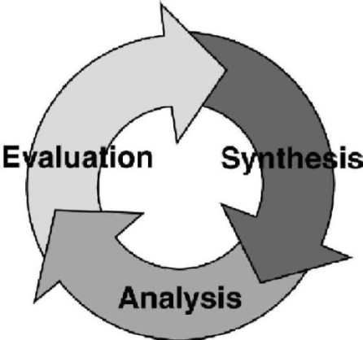

Figure 1. Synthesis, Analysis, and Evaluation Within SE

B. Commitment Incurred During System Design

The commitment to technology, system configuration, performance, and life-cycle cost is particularly acute during the early stages of system design. A large gap exists between this commitment and the system-specific knowledge available during conceptual and preliminary design as shown in Figure 2.¹⁸
It is essential that the technological activities of synthesis, analysis, and evaluation be integrated and applied iteratively over the system life cycle. This follows from the observation that the commitment to technology, configuration, product performance, and cost is particularly acute during early stages of the system life cycle, as is illustrated in Figure 2. The undesirable gap between commitment and system specific knowledge (A-A’ and B-B’) may be reduced by effective integration and adequate iteration as the design process evolves.²⁰

Great benefit can be derived from accelerating the accumulation of system specific knowledge earlier in the life cycle. Fully two-thirds of the commitment to final system characteristics and life-cycle cost is made by the time conceptual system design is finished. Powerful approaches utilizing modeling and indirect experimentation may be used to help narrow this gap. This section presents a paradigm based on the structure of normative models from the domains of operations research and systems analysis. The paradigm involves the identification and incorporation of design dependent parameters to link design characteristics with operational outcomes. Optimization and trade-off decisions are facilitated during the systems engineering process with the aid of a Design Evaluation Function and a Design Evaluation Display, both of which are described next.
Traditional engineering design has focused mainly on the acquisition phase of the product life cycle. But, experience indicates that a properly coordinated and functioning product or system, which is competitive in the marketplace, cannot be achieved through optimization efforts applied largely after it comes into being. Accordingly, it is essential that design optimization include operational considerations during the early stages of system development. The objective is to narrow the "gap" between available knowledge and commitment as was shown in Figure 2.

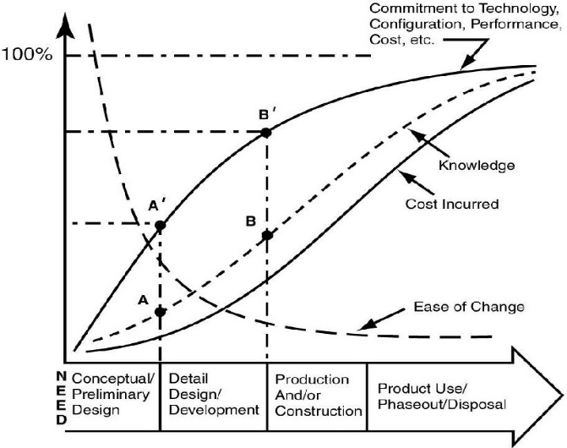

Figure 2. Commitment v Knowledge Accumulation Over The life-Cycle

Advancing the recent ASEE theme of “Value for Society” requires systems thinking more than ever before. Instead of offering systems or system elements per se, SA properly utilized within SE in this new century should facilitate the discovery of emergent system properties that provide desired functionality, capability, and improved operations.

C. The Design Dependent Parameter Paradigm

Each domain of engineering has its own customized analysis methodology for evaluation, and that is celebrated. But this paper emphasizes the importance of Design Dependent Parameters (DDP’s - operational outcomes beyond functionality inherent in the design that matter to stakeholders) that occur within all domains of engineering.

DDP’s are controllable along with design variables during the process of bringing systems and their products (human-made entities) into being. They are partitioned from Design Independent Parameters (DIP’s - externalities not controllable during design). This focus is most effective when based on design for the product life cycle, recognizing the concurrent life-cycle factors of production, support, phase-out; and disposal as is illustrated in the final entry within Figure 3.¹⁹

This innovative DDP paradigm originated and was promulgated based on the congruence of monetary time value and the time line known as the system life cycle. It is the money time value (MTV) principle from engineering economics (EE) and optimization (OPT) inherent in OR that jointly produces an advanced version of ‘equivalence’. Equivalence takes on an expanded meaning. The expansion establishes a fair basis for comparing mutually exclusive system design alternatives for each instance of the DDP’s, once they are predicted from design progress.
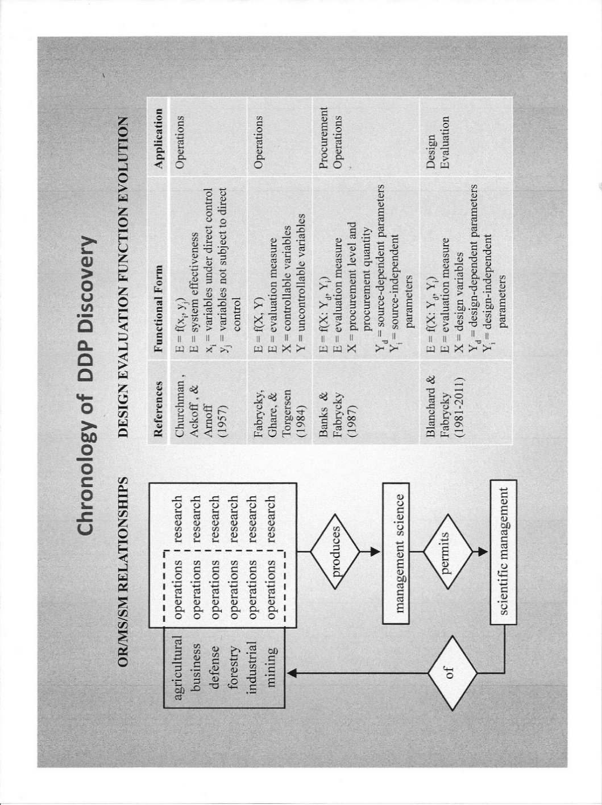
Figure 3. Evolution of the General Design Evaluation Function

Two related areas of Systems Analysis, Engineering Economics (EE) and Operations Research (OR), are referenced as prime examples. The EE/OR analysis connection is enabled by a Design Evaluation Function (DEF) derived over the system life-cycle. This function is central to deriving life-cycle cost from predicted design dependent parameter values that emanate from design iteration. Feeding mutually exclusive system design alternatives (first made equivalent) to a Design Evaluation Display (DED) as will be explained.

D. Development of Mathematics for Evaluating Systems
Consider Figure 3 (left side) regarding the evolution of a decision evaluation capability. Begin with operations and focus on the scientific management thereof. Operations are continuously being researched and an extensive body of systematic knowledge has accumulated, herein called Management Science (MS). MS properly utilized enables the practice of scientific management of the operations researched. This is a knowledge generation, knowledge accumulation, knowledge utilization process for industrial operations that originated more than a century ago.²⁰

Next, consider the right side of Figure 3 depicting the application of analysis within design and operations. The first two entries are decision model formulations applicable to operations in general, specifically for systems analysis. The third entry is explicitly for procurement and inventory operations with recognition of source dependent parameters, enabling better source selection decisions. Herein is the evolved mathematical basis and decision model background for systems engineering and systems analysis.

Design Dependent Parameters (DDP’s) began to appear in the fourth entry of Figure (right). These parameters (producibility, reliability, maintainability, supportability, sustainability, disposability, and others) make possible the evaluation of synthesized system designs. Design dependent parameters are the inner workings of the compass that helps converge systems design in the face of multiple criteria.

The DDP paradigm can now be indirectly traced to the classic Introduction to Operations Research, by Churchman, Ackoff, and Arnoff, 1957.²¹ In that year and with that pioneering OR book, it was your author’s good fortune to study the subject when a M.S. student here at Arkansas. But neither the book authors, the professor, nor yours truly could perceive what the generic mathematical construct stated in Chapter 1 could become for the unknown field of systems engineering.

The mathematical construct referenced in this classic book was E = f (x_{i,} y_{j}), with the explanation that it was the general form of OR models. It was stated that E represents the effectiveness of the system under study, x_{i} the variables of the system which are subject to control, and y_{j} those ‘variables’ (implying parameters) not subject to control.

That was all of it. The construct did not appear anywhere else in the book. Nor was it explained as the basic mathematical form behind any specific category of OR models. But, all models presented identified uncontrollables as those factors not taken to be decision or policy variables. These uncontrollable externalities included such factors as capacity, demand, economic indices, unit costs, and others. Since only operations, not design, was the implied application domain, this approach was somewhat useful. But, design variables and the Design Dependent Parameters of reliability, maintainability, producibility, disposability, and others were not mentioned or even recognized. An index search of modern OR books by yours truly failed to reveal citations that would embrace DDP’s, much less parameters in general.

With the publication of Applied Operations Research and Management Science by Fabrycky, Ghare, and Torgersen (Prentice Hall, 1984) a comprehensive mapping of Churchman, et. al. on most of the categories of OR/MS models became available.²² Although limited to the domain of operations, this textbook made explicit the role of parameters for the designation of certain uncontrollables for application in evaluating alternatives. This book was focused exclusively on the improvement of operations, mostly through optimization. The domain of design and design dependent parameters still had not been recognized, and herein is an interesting conjecture about the Oklahoma State dissertation produced by your truly!

It was not until the advent of USAF Project RAMCAD during 1986-88, with TRW and Virginia Tech as partners, that the need to rigorously evaluate design alternatives was specified as a deliverable. During the conduct of this research, system parameters were partitioned formally into design dependent and design independent subsets. The result was a Design Evaluation Function of the form E = f (X; Y_{d}, Y_{i}), shown last in Figure 3 and placed on the system life cycle as in Figure 4. Note that this brings OR and SA into the design sector where commitments need maximum attention!
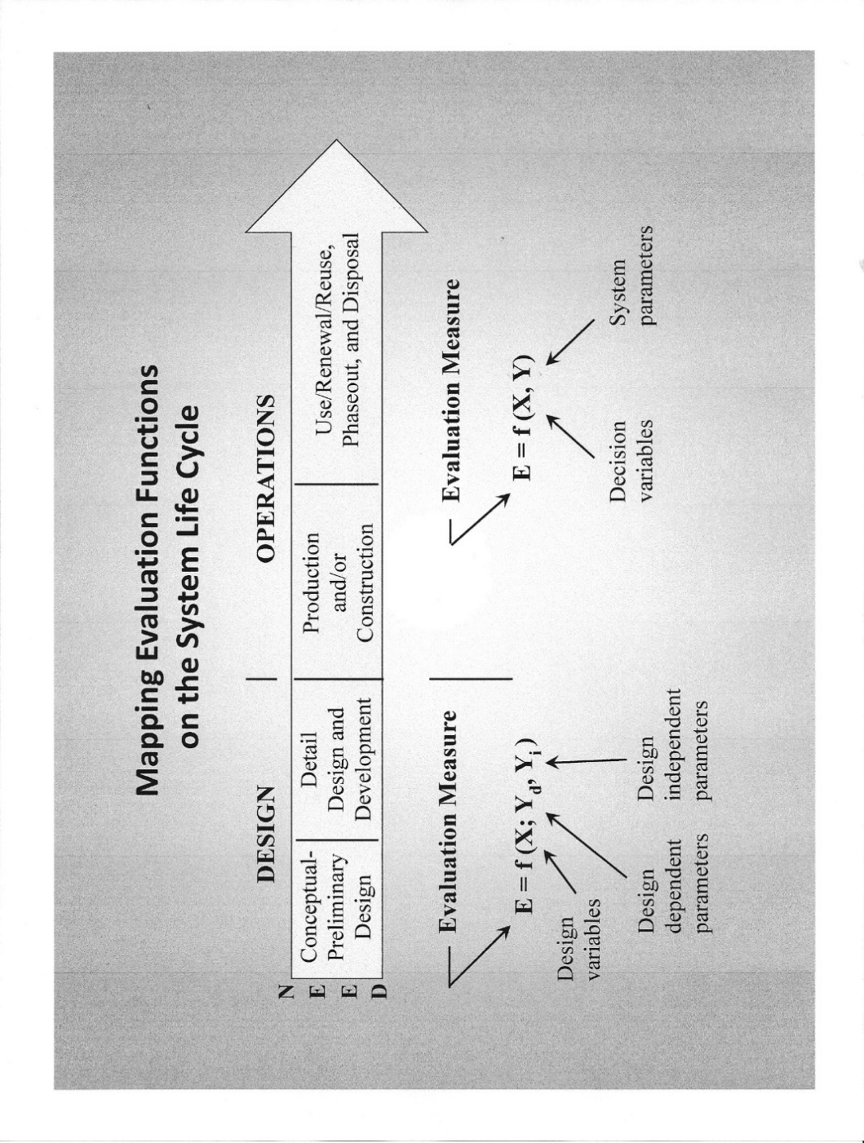Figure 4. Evaluation in Systems Design and Operations
Although too late for the First Edition in 1981, all subsequent editions of Systems Engineering and Analysis by Blanchard and Fabrycky incorporated the DDP concept for system design evaluation.³ Also, an added notion was adopted demonstrating that equivalence must be employed within each alternative; equivalence utilizing both money flow modeling and optimization modeling across design variables. Equivalence in this advanced context was shown to be essential for a valid and fair comparison of mutually exclusive alternatives.

E. A Morphology for Systems Engineering

A ten block morphology (form and structure) for capturing the high-level functions of Synthesis, Analysis, and Evaluation is illustrated in Figure 5 and discussed first at the level of Figure 1.

Synthesis. To design is to synthesize, project, and propose what might be for a specific set of customer requirements, often expressed in functional terms (Block 2). Synthesis is the creative process of putting known things together into new and more useful combinations. Meeting a need in compliance with customer requirements is the objective of design synthesis.
The primary elements enabling design synthesis are the design team (Block 3) supported by traditional and computer-based tools for design synthesis (Block 4). Design synthesis is often best
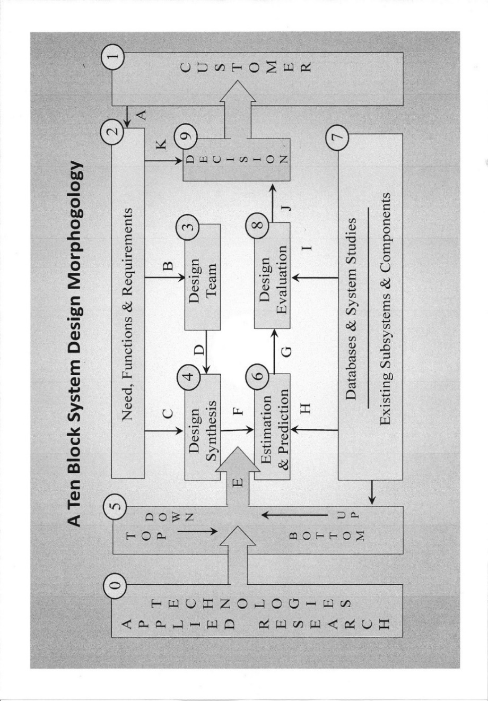Figure 5. A Morphology for the Engineering of Systems
accomplished by combining top-down and bottom-up activities (Block 5). Existing and newly developed components, parts, and subsystems are integrated to generate candidate system designs for analysis and evaluation.

Analysis. Analysis of candidate system or product designs is a necessary but not sufficient ingredient in system design evaluation. It involves the functions of estimation and prediction of design-dependent parameter (DDP) values (Block 6) and the forecasting of design-independent parameter (DIP) values from information found in physical and economic databases (Block 7).

Systems analysis and operations research provides a step on the way to system design evaluation, but adaptation of the models and techniques to the domain of design is required. The adaptation explicitly recognizes DDPs and incorporates the mandate of customer requirements.

Evaluation. Each candidate design (or design alternative) should be evaluated against other candidates and checked for compliance with all customers’ requirements. Evaluation of each candidate in Block 8 is accomplished after receiving DDP values for the candidate from Block 6. It is the specific values for DDPs that differentiate (or instance) candidate designs.

Design-independent parameter (DIP) values determined in Block 6 are externalities. They apply across all designs being presented for evaluation. Each candidate is made equivalent in Block 8 before being presented to the customer for design decision. (Block 9). It is in Block 9 that the best candidate is sought. The preferred choice is subjective and should be made by the customer.
F. Qualitative Description of the Morphology

This section presents a discussion of the functions accomplished by each block in the system design morphology of Figure 5. The discussion will be at a greater level of detail than the description of synthesis, analysis, and evaluation considered above.

The Technologies (Block 0). Technologies are the product of applied research as indicated in Block 0. They evolve from the activities of engineering research and development and are available to be considered for incorporation into candidate system designs. As a driving force, technologies are the most potent ingredient for advancing the capabilities of systems, products, structures, and services.

It is the responsibility of the designer/producer or contractor to propose and help the customer understand what might be for each technological choice. Those producers able to articulate and deliver appropriate technological solutions on time and within budget will attain and retain a competitive edge procurement competitions and/or in the global marketplace.

The Customer (Block 1). The purpose of system design is to satisfy customer (and stakeholder) needs and expectations. This must be with the full realization that the success of a particular design is ultimately determined by the customer, identified in Block 1.

During the design process, all functions to be provided and all requirements to be satisfied should be determined from the perspective of the customer, or the customer’s representative. Stakeholder and any other special interests should also be included in the “voice of the customer” in a way that reflects all needs and concerns. Included among these must be ecological and human impacts. Arrow A represents the elicitation of customer needs, desired functionality, and requirements.

Need, Functions, and Requirements (Block 2). The purpose of this block is to gather and specify the behavior of the product or system in functional terms. A market study identifies a need, an opportunity, or a deficiency. From the need comes a definition of the basic requirements, often in functional terms. Requirements are the input for design and operational criteria, and criteria are the basis for the evaluation of candidate system and product configurations.

At this point, the product or system should be defined by its function, not its form. Arrow A indicates customer inputs that define need, functionality, and operational requirements. Arrows B and C depict the translation and transfer of this information to the design process.

The Design Team (Block 3). The design team should be organized to incorporate in-depth technical expertise, as well as the broader systems view and thinking. Included must be expertise in each of the product life-cycle phases and elements contained within the requirements.

Balanced consideration should be present for each phase of the design. Included would be the satisfaction of intended purpose, followed by producibility, reliability, maintainability, sustainability disposability, environmental compliance, and others. Arrow B depicts requirements and design criteria being imposed on the design team and Arrow D indicate the teams contributed synthesis effort where need, functions, and requirements are the central consideration (Arrow C).

Design Synthesis (Block 4). To design is to project and propose what might be. Design synthesis is a creative activity that relies on the knowledge of experts about the state of the art as well as the state of technology. From this knowledge, a number of feasible design alternatives are fashioned and presented for analysis. Depending upon the phase of the product life cycle, the synthesis can be in conceptual, preliminary, or in detailed form.

The candidate design is driven by both a top-down functional decomposition and a bottom-up combinatorial approach utilizing available system elements through Block 5. Arrow E represents a blending of these approaches. Adequate definition of each design alternative must be obtained to allow for life-cycle analysis in view of the requirements. Arrow F highlights this definition process as it pertains to the passing of candidate design alternatives to design analysis in Block 6.

Alternatives should be presented for analysis even though there is little likelihood that they will prove to be feasible. It is better to consider many alternatives than to overlook one that may be very good. Alternatives not considered cannot be adopted, no matter how desirable they may have proven to be. Good advice for impatient students.

Top Down and Bottom Up (Block 5). Traditional engineering design methodology is based on a bottom-up approach. Starting with a set of defined elements, designers synthesize the product by finding the most appropriate combination of elements. The bottom-up process is iterative with the number of iterations determined by the creativity and skill of the design team, as well as by the complexity of the system design.

But, a top-down approach to design is inherent within the systems engineering process. Starting with requirements for the external behavior of any component of the system (in terms of the function provided by that component), that behavior is then decomposed. These decomposed functional behaviors are then described in more detail and made specific through an analysis process. Then, the appropriateness of the choice of functional components is verified by synthesizing the original entity.

Most systems and products are realized through a combination of the top-down and bottom-up approaches, with the best mix being largely a matter of judgment and experience. Arrow F represents the output of candidate designs made ready for analysis.

Estimation and Prediction (Block 6). Cost and effectiveness measures are generated during estimation and prediction, using models and database information, to obtain design-dependent parameter (DDP) values for each design alternative (Block 6). These models and simulations are based on physical laws, assumptions, and empirical data.

The DDP values provide the basis for comparing system designs against input criteria to determine the relative merit of each candidate. Arrow H represents input from the available databases and from relevant studies.

Physical and Economic Databases (Block 7). Block 7 provides a resource for the design process, rather than being an actual step in the process flow. At this point, design-independent parameter (DIP) values are determined and provided to the activity of design evaluation via Arrow I.
There exists a body of knowledge and information that engineers, economists, and technologists rely on to perform the tasks of analysis and evaluation. This knowledge consists of physical laws, empirical data, price information, economic forecasts, and other studies and models.

Block 7 also includes descriptions of existing system components, parts, and subsystems. It is important to use existing databases in doing analysis and synthesis to avoid duplication of effort. This body of knowledge and experience can be utilized both formally and informally in performing needed studies, as well as in supporting the decisions yet to follow.

Design Evaluation (Block 8). Design evaluation is an essential activity within system and product design and the systems engineering process. It should be embedded appropriately within the process and then pursued continuously as product design and development progresses.

Life-cycle cost is one basis for comparing alternative designs that otherwise meet minimum requirements specified under performance criteria. The life-cycle cost of each alternative is determined based on the activity of estimation and prediction just completed. Arrow J indicates the passing of the evaluated candidates to the decision process. The selection of preferred alternative(s) can only be made after the life-cycle cost analysis is completed and after effectiveness measures are defined and applied.

Design Decision (Block 9). Given the variety of customer needs and perceptions as collected in Block 2, choosing a preferred alternative is not just the simple task of picking the least expensive design. Input criteria, derived from customer and product requirements, are represented by Arrow K and by the DDP values and life-cycle costs indicated by Arrow J. The customer or decision maker must now trade off life-cycle cost against effectiveness criteria subjectively. The result is the identification of one or more preferred alternatives that can be used to take the design process to the next level of detail. Alternatives must ultimately be judged by the customer. Accordingly, Arrow L depicts the passing of evaluated candidate designs to the customer for review and decision.

Alternatives that are found to be unacceptable in performance terms can be either discarded or reworked with new alternatives sought. Alternatives that meet all, or the most important, performance criteria can then be evaluated based on estimations and predictions of DDP values. This should be accompanied by an assessment of risk.
Within the context of synthesis, analysis, and evaluation is the opportunity to implement systems engineering over the life cycle in measured ways that can help ensure its effectiveness in professional practice. It is a morphology for linking applied research and technologies (Block 0) to customer needs (Block 1). It also provides a structure for visualizing the technological activities of synthesis, analysis, and evaluation. Each of these activities is summarized in the paragraphs that follow, with reference to relevant blocks within the morphology.

G. Economic Models for System Evaluation

Two broad categories of analytical models are central to formulating a Design Evaluation Function for evaluating mutually exclusive design alternative. These are Money Flow Modeling and Economic Optimization Modeling.²³

Money Flow Modeling. Money flow modeling is central to the field of Engineering Economics (EE). Engineering economics has always been associated with time; the time value of money, receipts and disbursements over time, etc. The central “model” in engineering economics is the money flow diagram, depicting estimates of income and outlay over time. Accordingly, EE and the product or system life cycle are on the same “dimension”.

Algebraic expressions for the Present Equivalent (PE), Annual Equivalent (AE), and the Future Equivalent (FE), as well as expressions for the Internal Rate of return and the Payback Period are well known in EE. A general economic equivalence function subsuming each of these equivalence approaches is given in Figure 6.
To Determine Cost Equivalence
Over the System and Product Life-Cycle

Utilize the Economic Equivalence Function
PE, AE, or, FE = f (F_{t}, i, n)

Figure 6. Equivalence Function for Money Flow Analysis
Symbols in the Equivalence Function are defined as follows:

F_{t} = positive or negative money flow at the end of year t
t = 0, 1, 2, . . . , n
i = annual rate of interest
n = number of years

There is nothing new here except recognition that EE and life-cycle mapping, as in Figure 4, have much in common. System thinking at a higher level is the key consideration.

The Present Equivalent, Annual Equivalent, or Future Equivalent amounts are consistent bases for the evaluation of a single alternative, or for the comparison of mutually exclusive alternatives. These bases for comparison are actually decision numbers, not budgetary amounts.

A disadvantage of money flow modeling is that design dependent parameters are implicit. This is also true of design variables. Both of these are made explicit by economic optimization modeling as presented next.

Economic Optimization Modeling. Design evaluation in terms of life-cycle cost and system effectiveness can be facilitated by adopting the Design Dependent Parameter approach. This approach is a mathematical way to link design actions with operational outcomes. It utilizes a Design Evaluation Function (DEF) illustrated in Figure 7 (also see Figure 2).

To Optimize Within Each Alternative
Mathematically Link Design and Operations
Utilizing the Design Optimization Function
Equivalent LCC = f (X; Y_{d}, Y_{i})

Figure 7. Equivalence Function for Economic Optimization

The following definitions of terms apply to the DEF in Figure 6:

E = a life-cycle complete evaluation measure such as equivalent life-cycle cost (PE, AE, or FE)
X = design variables (e.g., number of deployed units, membrane thickness, retirement age, repair channels, rated thrust, pier spacing, etc.)
Y_{d} = design dependent parameters (e.g., weight, reliability, design life, capacity, producibility, maintainability, supportability, etc.)
Y_{i} = design independent parameters (e.g., energy cost, cost of money, labor rates, material cost per unit, shortage cost penalty, etc.)

The Design Evaluation Function must be linked to all phases of the system life cycle. This function, incorporating both design dependent and design independent parameters, facilitates design optimization. It provides the basis for a clarification of the true difference between alternatives (a design-based choice) and optimization (an analysis-based choice)

H. Choosing the Preferred Alternative

The Decision Evaluation Display (DED) method of making decisions is presented in Figure 8 (and preferred for choosing from among mutually exclusive design alternatives and/or candidate systems). Some decision makers consider ranking, elimination, weighting, rating, and similar selection rules to be impediments to the effective application of insight, intuition, and judgment. An alternative is to put the emphasis on visually displaying and communicating only the differences upon which a decision depends, leaving the remaining path to a decision to the decision maker.

The DED is based on the premise that differences between alternatives and the degree of compliance with multiple criteria are all that most decision makers need or desire. Experienced decision makers possess an inherent and acquired ability to process information needed to trade off competing criteria. Accordingly, the decision evaluation display is recommended as a means for simultaneously exhibiting the differences that multiple alternatives create in the face of multiple criteria. Component parts of the DED are explained below:

- Alternatives (A_{1,} A₂, A₃). Two or more alternatives appear as vertical lines in the field of the decision evaluation display.
- Equivalent Life-Cycle Cost. The horizontal axis represents present equivalent, annual equivalent, or future equivalent cost. Specific cost values are indicated on the axis for each alternative displayed, with cost increasing from left to right. In this way, equivalent economic differences between alternatives are made visible.
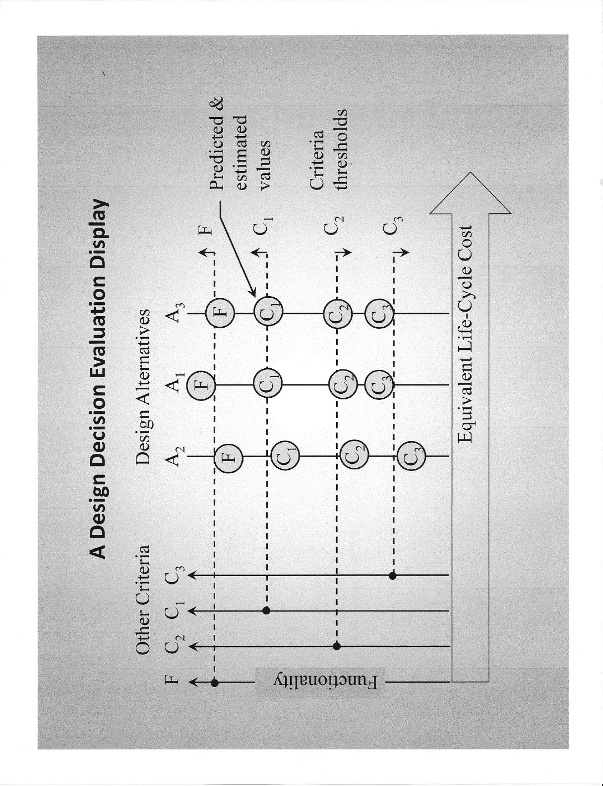Figure 8. The Decision Evaluation Display for Multiple Criteria

- Functional criteria (F). Functions individually, or all together and represented by a derived index, appear at the far left of the vertical axes.
- Other criteria (C_{1,} C_{2,} C₃). Other vertical axes represent one or more criteria, usually noneconomic in nature. Each axis has its own scale, depending upon the nature of the factor represented.
- Other criteria thresholds. Horizontal lines emanating from all vertical axes represent threshold or limiting values for functional and noneconomic criteria (less than, equal to, or greater than).
- Predicted and/or estimated values. Anticipated outcomes for each alternative (based on prediction and/or estimation) are entered in circles placed above, on, or below the thresholds. Thus, differences between desired and anticipated outcomes for alternatives are made visible.

Equivalent cost (or profit) from Figure 6, or from Figure 7, or from a DEF combining both, is shown on the horizontal axis of Figure 8 as an objective measure. The aim in decision making is to select the mutually exclusive alternative with the lowest equivalent cost (or maximum equivalent profit) that adequately satisfies the other criteria.

Multiple criteria considerations arise in life-cycle cost analyses during design when both economic and non-economic factors are present in the evaluation. Accordingly, design evaluation in terms of life-cycle cost and system effectiveness is an area in need of attention by the producer and customer acting together. In this situation, a Design Evaluation Display, simultaneously exhibiting both cost and effectiveness measures can be quite helpful.

Requirement thresholds are shown on the display. These are useful to the decision-maker in assessing the degree to which each alternative meets functional and other criteria. This approach is recommended for most applications, because subjective evaluation by the customer and producer can be directly accommodated in a visible way. Trade-offs become visible and can be subjectively considered
Summary and Conclusions for Section II

Legions of academicians and practicing professionals are continuing to develop and apply powerful tools for analysis, experimentation, modeling, simulation, animation, etc. to the domain of operations. These individuals represent the fields of industrial engineering, engineering management, operations research, management science, systems management, and others. Too often the well- intended efforts of these individuals are mistakenly called "systems engineering". These important domains and professional fields are necessary but not sufficient.

Some important areas in need of consideration for improvement in systems engineering education and professional practice are:

- Systems analysis is necessary but not sufficient for SE, and this finding should be imparted in the teaching of each area, with full recognition of the potential value of their integration.
- Design dependent parameters are the key to linking system design to the world being modified by design and all impacted people.
- A DDP based design evaluation function, traceable to OR, should better guide the teaching of design space exploration within the functional domain, backed by equivalence based on life-cycle economics and design optimization, now imparted by separate courses.
- When driven by synthesis and the prediction and/or estimation of DDP values, and the incorporation of optimization across design variables, design evaluation will likely become the key to continuous operational improvement through system design.
- Design impacts on the natural world, including humans, should be incorporated in academic course work (including undergraduate capstone projects) and the project or thesis research required for a graduate SE degree.
- Graduate study in SE should focus on preparing candidates for service as engineering interdisciplinarians, who think always about “the end before the beginning”.
7. The overarching goal should be to promulgate systems thinking focused on the human - made world; that is, the world emerging from system design by humans.¹⁰
Entirely too much engineering time and talent is being expended addressing operational deficiencies plaguing the human-made world. Operational problem mitigation will always be needed, but the dramatic payoff for humankind lies in operational problem avoidance through system thinking, as recommended for addressing pervasive grand challenges.¹¹

SECTION III – SOME SYSTEM DESIGN EXAMPLES
System design examples are presented and discussed in this section. The first three are descriptive only, covering diverse situations. Quantification of the described situations may be found in the cited literature. The fourth is developed almost fully and addresses a common systems architecture, that involving homogenous deployed populations of repairable entities. By reference thereto, the reader will obtain a more complete understanding of system evaluation methodology based on life-cycle economic analysis.^{3,23}

A. Three Simple Examples Described in Words

Moving Electrical Energy. Electrical energy cannot be stored in large amounts economically. Accordingly, there is a continuing need to move electricity from sources to points of use. Electrical energy is moved from generating plants to substations and then from there to the transmission grid. In industrial applications, electrical energy is moved to energy intensive processors such as autoclaves, forges, rolls, smelters, etc.

In these situations, transmission lines, buss bars, and conductors are use as the means of interconnection. They must be designed and produced from a metallic material, the selection of which constitutes a mutually exclusive design alternative. Each candidate material has its own conductive and other properties. These are design - dependent parameters.

Then, there is the question of the loss of energy during transmission. Energy loss depends upon the material selected, as well as the specified cross sectional area of the conductor. This loss can be reduced by specifying a large cross sectional area. But, in so doing, the investment cost in the conductor will be large. By identifying the cross sectional area as a design variable, one may optimize (minimize) the life-cycle cost for each feasible material type being considered.

Other criteria may then be considered and added to complete the decision situation. Among these may be aesthetics, availability, design life, etc. Finally, a Design Evaluation Display may be used to visually compare alternatives in the multi-criteria domain.

Crossing an Obstacle. Obstacles must often be crossed whenever people, vehicles, equipment, and goods are to be moved from one place to another. Among these obstacles are water bodies, railroads, highways, and difficult geographic features. In some of these cases, a bridge may be the best solution when compared to a tunnel or an airlift capability. Determination of the best approach is the purpose of conceptual design.

Consider the problem of designing a superstructure to support entities traversing an obstacle, perhaps a highway. Each possible superstructure design will have a unique configuration and load carrying capacity. It will require a substructure of piers (and abutments) that can be spaced close together, or far apart. In this situation, the superstructure configuration is the design alternative and the pier spacing is the design variable.

The first (or constructed) cost of the bridge is the sum of the costs of the superstructure and the piers. This cost may be minimized for each design alternative by seeking the pier spacing that is optimal (minimum). It can then be augmented with money (cost) flows over time arising from operation and maintenance costs; again for each superstructure design alternative.

The final step is to enter the available superstructure design alternatives on a Design Evaluation Display. Life-cycle cost is the objective measure that should appear on the horizontal axis. In the vertical direction, axes will be provided for aesthetics, structural safety, and any other measures that reflect the relative merit of one design over another.

Procuring and Storing Consumables. Multisource procurement and inventory operations lead to warehouse or storage facility design that depends upon three decisions; the procurement level for stock replenishment, the procurement quantity, and the procurement source. For each procurement source possibility, there exists a set of source dependent parameter values. These are the procurement lead time, the procurement cost per procurement, and the replenishment rate.

Optimal procurement and inventory policy for consumable items can be derived by minimizing the sum of item cost, procurement cost, holding cost, and shortage cost. This should be accomplished for each mutually exclusive source alternative by finding the minimum cost values for the procurement level and the procurement quantity (optimization across two decision variables). Each source alternative may then be entered onto a Decision Evaluation Display that incorporates other criteria. Some of these are source (supplier) dependability, storage space congestion, worker safety, etc. The system manager can then select the source that best meets the several effectiveness criteria in the face of total annual cost.

B. Repairable Equipment Population Systems (REPS)
Consider the following situation: A finite population of repairable equipment is to be procured and maintained in operation to meet a demand. As equipment units fail or become unserviceable, they will be repaired and returned to service. As they age, the older units will be removed from the system and replaced with new units. The system design problem is to determine the population size, the replacement age of units, and the number of repair channels for each set of design dependent parameters in the face of design independent parameters so that design requirements will be met at a minimum life-cycle cost.
A general schematic of REPS is shown in Figure 9. Both the airlines and the military acquire, operate, and maintain aircraft with finite population characteristics. In ground transit, vehicles such as taxicabs, rental automobiles, and trucks constitute repairable equipment populations. Production equipment types such as machine tools, weaving looms, and autoclaves are populations of equipment known as producer goods. In housing, populations of dwelling units come into being after a construction process. But, the repairable entity may exist as part of an inventory of components for a prime equipment population. For example, aircraft hydraulic actuators, water pumps, automobile starters and alternators, and automation controllers are all repairable components that must be acquired to meet a higher-level system need.

Introduction to REPS. Suppose that a finite population of repairable equipment is to be procured and maintained in operation to meet a demand or need. As repairable equipment units fail or become unserviceable, they will be repaired and returned to service. As they age, the older units will be removed from the system and replaced with new units. The system problem is to determine the population size, the replacement age of units, the number of repair channels, the design mean time between failures, and the design mean time to repair, so that design requirements will be met at a minimum life-cycle cost. This situation is classified as a multi-entity population system to distinguish from single entities.

Two problem versions are treated in this example. The first is to determine the population size, the replacement age of units, and the number of repair channels so that the sum of all life-cycle costs associated with the system will be minimized. This is a problem in optimizing operations and will be referred to REPS Optimization. The second problem is to evaluate candidate system designs by predicting both the unit mean time between failures (MTBF) and the unit mean time to repair (MTTR) as a function of unit cost, as well as the derived optimal population size, the replacement age of units, and the number of repair channels. This is a design situation referred to as REPS System Design.

The Operational System. The repairable equipment population system illustrated in Figure 9 is designed and deployed to meet a demand, D. Units within the system can be separated into two groups: those in operation and available to meet demand, and those out of operation and hence unavailable to meet demand. It is assumed that units are not discarded upon failure, but are repaired and returned to service.
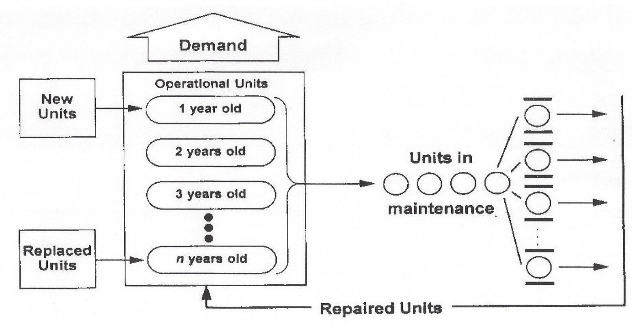

Figure 9. The Reparable Population System Schematic

As units age, they become less reliable and their maintenance costs increase. Accordingly, it is important to determine the optimum replacement age. It is assumed that the number of new units procured each year is constant and that the number of units in each age group is equal to the ratio of the total number required in the population and the desired number of age groups. Although the analysis deals with the life cycle of the units, the objective is to optimize the total system of which the units are a part. This is in keeping with the system/product relationship that exists for finite population systems.
In the REPS Optimization Problem, the decision process consists of specifying a population of units, a number of maintenance channels, and a replacement schedule for bringing new units into the system. For REPS Design Problem, the decision process is extended to include establishing the unit’s reliability and maintainability characteristics. In either case, the system is to be designed to meet the demand for equipment to satisify multiple criteria.

Scope and assumptions. Repairable equipment population systems normally come into being over a non-steady state buildup phase. They then operate over a steady-state interval of years, after which a phase-out period is entered. Only the steady-state mode of operation will be considered.
The following assumptions are adopted in the development of the mathematical model and algorithm for REPS:

1. The interarrival times are exponentially distributed.
2. The repair times are exponentially distributed.
3. The number of units in the population is small such that finite population queuing formulations must be used.
4. The interarrival times are statistically independent of the repair times.
5. The repair channels are parallel and each is capable of similar performance.
6. The population size will always be larger than or at least equal to the number of service channels.
7. Each channel performs service on one unit at a time.
8. MTBF and MTTR values vary for each age group and represent the expected value for these variables for that age group.
9. Units completing repair return to operation with the same operational characteristics as their age group.

Evaluation of the REPS Optimization Problem. Applying the decision evaluation function of Equation xx. Here the objective is to find optimal values for controllable design variables in the face of uncontrollable system parameters. In REPS Optimization, the decision evaluation function of Equation xx is used to seek the best candidate system. This is accomplished by establishing values for controllable design-dependent parameters in the face of uncontrollable design-independent parameters and optimal values for design variables.
Three design variables are identified in the repairable equipment population system. These controllables are the number of units to deploy, the replacement age of units, and the number of repair channels. Optimal values are sought for these variables so that the sum of all costs associated with the repairable equipment population system will be minimized.

In the Opmization Problem the focus is entirely on optimizing design variables as the only controllable factors. This situation arises when the system is in existence and the objective is to optimize its operation in the face of uncontrollable system parameters. The focus shifts to seeking the best candidate system in the Design Problem. In this activity, optimal values for design variables are secondary. They are needed as a means for comparing candidate systems equivalently with the time value of money considered. Then, when the best system design is identified, specific values of decision variables are implemented to assure its optimal system operation.

Demand is the primary stimulus on the repairable equipment population system and the justification for its existence. This uncontrollable system parameter is assumed to be constant over time. Other uncontrollable system parameters are economic in nature. They include the shortage penalty cost which arises when there are insufficient units operational to meet demand, the cost of providing repair capability, and the time value of money on invested capital.

Some system parameters are uncontrollable in REPS Optimization, but controllable in the REPS Design Problem. These are the design MTBF and MTTR, the energy efficiency of equipment units, the design life of units, and the first cost and salvage value of deployed units. It is through these design-dependent parameters that the best candidate system may be identified.

A mathematical model for system design evaluation can be formulated using the evaluation function of Figure 7. The model uses annual equivalent life-cycle cost as the evaluation measure where

REPS Optimization Problem. In this REPS example, the decision maker has no control over system parameters but can only choose the number of equipment units to procure and deploy, the age at which units should be replaced, and the number of channels in the repair facility.

Assume that the demand, D, is for 15 identical equipment units. Table 4 lists system parameters for this example.

Table 4 summarizes the design variables and system parameters for REPS. Note that the design dependent parameters of unit cost (Cu), reliability (MTBF), and maintainability (MTTR) are central to the system design problem.
Table 4 Design Variables and System Parameters for REPS
Variables/Parameters | Design  Var. | Design  Dep. | Design  Ind.
D = Demand for deployed units |  |  | X
N = Number of units deployed | X
M = Number of maintenance channels | X
n = Retirement age of deployed units | X
Cu = Annual equivalent unit cost per unit |  | X
Cr = Annual channel cost per channel |  |  | X
Cs = Shortage cost per unit short per period |  |  | X
MTBF = Mean time between unit failure |  | X
MTTR = Mean time to repair a unit |  | X

D. REPS Design Alternatives
Consider two REPS design alternatives (candidate systems) for which decision variables and system parameters are shown in Table 4. REPS presents an operations improvement opportunity if the system is already in being; that is, if design dependent parameters are not any longer in the design stage. A system design problem is in existence if a REPS system is being brought into being. Design Dependent Parameter values are in play during the design process.
Consider a hypothetical situation with just two design iterations exhibited. The major cost components for the Decision Evaluation Function are:
1) Population Annual Equivalent Cost:
PC=CuN
where
2) Repair Facility Annual Equivalent Cost:
RC=CrM
3) Annual Shortage Cost:
SC=Cs[E(S)]
where
Is derived from finite population queueing theory, with P(N-D+j) being the probability of shortage ranging from 0 to D units. Alternatively values may be taken from the Peck and Hazelwood tables.
Table 6 gives a summary of the optimization results for effectiveness measures (cost and shortages) and system design variable values. From this it is evident that Candidate B is best on the basis of life-cycle cost. However, Candidate A is best on the probability of one or more units short as well as on the average MTBF value (see Table 2).

Table 5. System Parameters for REPS

Variables / Parameters | Candidate A | Candidate B
Demand | 15 | 15
Shortage cost per day | $200 | $200
Interest rate | 10% | 10%
Cost of equipment unit* | $55,000 | $44,000
Salvage value* | $7,000 | $6,000
Design life (years)* | 6 | 6
Average MTBF (years)* | 0.316 | 0.210
Average MTTR (years)* | 0.054 | 0.043

Table 6. Optimized Outputs for REPS
Output Item | Candidate A | Candidate B
Population cost | $228,986 | $202,804
Repair facility cost | $179,804 | $179,804
Shortage penalty cost | $ 32,329 | $ 51,794
Expected (AELCC) | $441,119 | $434,402
Probability of one or more short | 0.214 | 0.288
Mean units short | 0.44 | 0.71
Means units down | 3.15 | 4.36
Total number of units deployed | 19 | 20
Repair channels | 4 | 4
Retirement age | 5 | 3

Design variable values are also shown in Table 7. These are to be used to implement optimal procurement and operating policy in the face of design requirements. For example, assume that the design requirements are:
- Design to cost - the deployed population shall have a first cost not exceeding $1,000,000.
- Probability of shortages - the probability of one or more equipment units short of demand shall not exceed 0.25.
- Reliability - the mean time between failure for equipment units shall not be less than 0.3 years.

Selection of the best alternative (candidate system) in the face of design requirements is facilitated by the Design Evaluation Display illustrated in Figure 14.

The shortage probability histogram for this example is exhibited in Fihure 14

Figure 14. Probability of one or more units short of demand.

SECTION IV – PORTFOLIO ANALYSIS, DOING THE RIGHT DESIGNS
Doing system or product design right is too often the primary focus of an enterprise. Ordinarily there will be many different products being designed, developed, and marketed by the firm. It is assumed now that each product is being designed right by utilizing the methodology presented in Sections II and III, or its equivalent best practices. That is, assume that the design of each product is being subjected to a continuous product evaluation process, including use of a DED or similar interface display with the customer.

A. The Portfolio of Systems or Products

A product portfolio exists within the firm when two or more products or projects are in existence. When this is the case, scarce resources are allocated to the products with the anticipation of returns greater than the costs thereof. The objective is to determine the most profitable portfolio to have in existence at any point in time, so that the future wealth of the firm will be maximized. That is, a mix of the right products is sought by product portfolio analysis.

Figure 7 illustrates a hypothetical product portfolio, with product life cycles shown by simple resource profiles. Negative, ‘below the line’ profile segments indicate resources being incurred at a cost. Positive, ‘above the line’ profile segments indicate net returns. Note that the ‘Today’ line partitions each product into its past (with sunk cost revealed) and its future (based on cost and net revenue estimates). Portfolio evaluation, intended to select the right set of products at any point in time, is done over only the portion of the life cycle to the right of the ‘Today’ line.

Figure 7. A Hypothetical Product Portfolio

All products under consideration in the portfolio need not have the same life cycle; unequal lived products may be accommodated, as Figure 7 shows. Available products may have their resource consumption needs and net revenue flows estimated in accordance with discrete or continuous functions. In Figure 7, continuous functions are utilized and described next:

- Product 1 was designed and developed several periods ago. It continues to generate significant net revenue that is just now beginning to decline.
- Product 2 has just completed its design and development phase and is to begin generating net revenue in the next period.
- Product 3 is completing estimated expenditures in the next two periods, after which it is expected to generate a long-term net revenue flow. This product is the longest lived in the portfolio and it defines the planning horizon for portfolio analysis.
- Product 4 has just entered its revenue generating cycle, with its design and development costs having ended two periods ago.
- Product 5 is being considered as a new project. It has an anticipated design and development cycle spanning five periods, to be followed by a net revenue cycle over seven periods.

- Resource Allocation to Products

Resource allocation to products is conducted in a dynamic resource constrained environment. In each period of the process, only estimated values are available for product costs, product net returns, and system parameters. Product interdependencies must also be considered in allocating the firm’s limited capital among the active products in the portfolio.

Each designer (or design team) should be required to periodically provide anticipated resource consumption needs to the product portfolio manager. The designer should report estimates of the life-cycle cost elements by period, in accordance with a cost breakdown structure. These estimates should derive from the design and from the anticipated resources required to develop, produce, distribute, support, and dispose of the product. Then, in cooperation with marketing, the anticipated revenue stream should be similarly reported. By exhibiting the resulting plus / minus profile, the portfolio manager can continuously determine if the right products are being developed, marketed, distributed, and phased out.

It is important to recognize that decisions made in the present affect investments of resources, which are to be made in the future. Decisions to invest in products now result in the absorption of resources which could have been held over and allocated to products that might contribute a higher equivalent value to the portfolio.

Product Funding Over Time. Upon completing the resource allocation in one period, the chosen products are funded until the end of the period. These products are then considered, along with new product initiatives, and the process is repeated. This makes the resource allocation decision in one period only one of a long series of such decisions.

At each decision point, two types of products must be considered; those that are ongoing and those that have not yet been initiated (project not yet established). For ongoing products, the portfolio manager must decide if a product in the portfolio should receive increased funding, decreased funding, unchanged funding, or no funding at all (product cancellation). These decisions will dynamically alter the cost and revenue profiles for the products that were shown in Figure 7.
Various constraints are usually present. These may include mutual exclusivities, contingencies, and resource limitations. The decision may also be constrained by non-economic factors such as a requirement that a certain product be included in the ongoing portfolio, regardless of its economic viability. This is a “must fund” requirement.

Portfolio Creation Process. To correctly consider an allocation decision when n products are available, the portfolio manager must analyze 2 to the n th power different product combinations. The resource allocation decision is not only large in scope, but it is conducted in a dynamic environment that changes from decision period to decision period.

The widely used concept of deriving cost flows per product (product) has serious weaknesses when resources are shared by different products. This is certainly the case with product portfolio analysis as presented in this section. It is possible to avoid cost allocation to competing activities if a portfolio approach is used where costs are considered only in the acquisition and utilization of resources, as in reference (X).

Methods of Portfolio Selection. There are three methods for determining the best mix of products to have in the portfolio at any point in time. These are discussed briefly below:
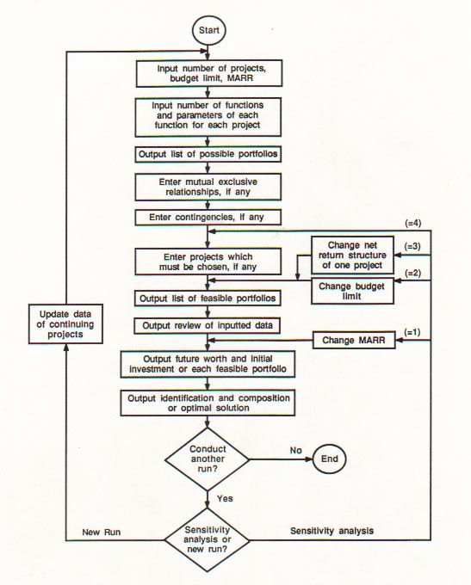
Figure 8. Portfolio Generation Process
- Heuristic portfolio selection - The heuristic or empirical method of portfolio selection is often used, but it is not rigorous. It is based on an informal connection between product design and development people and management. This method depends upon judgment based upon interaction between the designer and management. The use of analytical methods, models, and computer aided tools is usually minimal. This approach works best for small firms offering few products.
- Selection by rank on rate-of-return - Rank on rate-of-return (ROR) is a formal analytical method that uses money flow modeling as indicated in Figure 5. The computation for ROR is based on the cost profiles and net revenue projections projected product-by-product.
- The budget impact caused by each product must be listed along with the ROR for each. Then, this information is gathered periodically as a basis for selecting the portfolio for the next period. Some products will not be initiated and others will be discontinued because their ROR falls below the minimum acceptable rate of return (MARR). This portfolio selection method is easily explained and is somewhat rigorous.
- Selection by portfolio future worth - The FW method is based on the future equivalent (FE) criterion (use either Figure 6 or 7 as the applicable mathematical form). The procedure presented there utilized the future equivalent worth of net return criterion in making a recommended product portfolio selection. Selection of a preferred portfolio requires the creation of an exhaustive zero-one matrix of product possibilities, with reduction in the number of portfolios accomplished by the application of one or more constraints.

The best product combination is determined from the feasible set by calculating the FW based on a MARR during the life of each product and moved to the end of the planning horizon utilizing the market cost of money. This is a rigorous and cumbersome selection method.

Summary and Recommendations for Section IV

The theme of this section is that of design complexity from the perspective of the firm, not just from the perspective of the product. Design complexity, as addressed herein, derives from the desirability of doing the design right and also from doing the right design. Design complexity results from looking beyond the design of an individual product.

Relatively speaking, it is easier to do design ‘right’ if the interactions between product designs are ignored. In this commonly adopted situation the designer, or design team, need not be concerned about the issue of doing the right design. Neither is it necessary to be concerned about the best allocation of resources to the product and its production, distribution, and support activities over the applicable life cycle. Although this narrow view is tempting, it is not best for the long-term financial health of the firm.

Some important areas in need of consideration for improvement in systems engineering education and professional practice are:

- Systems analysis is necessary but not sufficient for SE, and this finding should be imparted in the teaching of each area, with full recognition of the potential value of their integration.
- Design dependent parameters are the key to linking system design to the world being modified by design and all impacted people.
- A DDP based design evaluation function, traceable to OR, should better guide the teaching of design space exploration within the functional domain, backed by equivalence based on life-cycle economics and design optimization, now imparted by separate courses.
- When driven by synthesis and the prediction and/or estimation of DDP values, and the incorporation of optimization across design variables, design evaluation will likely become the key to continuous operational improvement through system design.
- Design impacts on the natural world, including humans, should be incorporated in academic course work (including undergraduate capstone projects) and the project or thesis research required for a graduate SE degree.
- Graduate study in SE should focus on preparing candidates for service as engineering interdisciplinarians, who think always about “the end before the beginning”.
- The overarching goal should be to promulgate systems thinking focused on the human - made world; that is, the world emerging from system design by humans.¹⁰

Legions of academicians and practicing professionals are continuing to develop and apply powerful tools for analysis, experimentation, modeling, simulation, animation, etc. to the domain of operations. These individuals represent the fields of industrial engineering, engineering management, operations research, management science, systems management, and others. Too often the well- intended efforts of these individuals are mistakenly called "systems engineering". These important domains and professional fields are necessary, but not sufficient.

Entirely too much engineering time and talent is being expended addressing operational deficiencies plaguing the human-made world. Operational problem mitigation will always be needed, but the dramatic payoff for humankind lies in operational problem avoidance through system thinking, as recommended for addressing pervasive grand challenges.¹¹

SECTION V. REFERENCES

- Panitz, B., Senior Editor, Training Technology’s Maestros, American Society for Engineering Education, PRISM, November, 1997.
- Fabrycky, W. J., Systems Engineering: Its Emerging Academic and Professional Attributes, Proceedings, ASEE Annual Conference and Exposition, Louisville, KY, June 21, 2010.
- Blanchard, B. S. and W. J. Fabrycky, Systems Engineering and Analysis, Fifth (30th Anniversary) Edition, Pearson Prentice Hall, 2011.
- Bode H. W., Report to the Committee on Science and Astronautics, U. S. House of Representatives, Washington, DC, 1967.
- INCOSE Fellows Special Journal Issue, Systems Engineering, Vol. 1, No. 1, July - September, 1994.
- EIA/IS 632, Systems Engineering, Electronic Industries Alliance, 2500 Wilson Boulevard, Arlington, VA, 1994.
- DSMC, Systems Engineering Management Guide, Defense Systems Management College, Superintendent of Documents , U.S. Government Printing Office, Washington, DC,1990.
- IEEE P1220, Standard for Application and Management of the Systems Engineering Process, Institute of Electrical and Electronics Engineers, 345 East 47th Street, New York, NY, 1994.
- DOD Instruction 5000.02, Operation of the Defense Acquisition System, Enclosure 12 on Systems Engineering, December, 2008.
- Educating the Engineer of 2020, National Academy of Engineering, Washington, DC: National Academy Press, 2005
- International Council on Systems Engineering (INCOSE), Administrative Offices, 7670 Opportunity Road, Suite 220, San Diego, CA.
- Fabrycky, W. J. and E. A. McCrae, Systems Engineering Degree Programs in the United States, Proceedings, 15th Annual International Symposium, INCOSE 2005, Rochester, NY, July, 2005.
- Peterson’s Guides, Programs in Engineering and Applied Science, Thompson Learning, Volumes for 2004-09.
- Criteria for Accrediting Engineering Programs, Engineering Accreditation Council of ABET for Accreditation Cycle 2014 - 2015.
- Fabrycky, W.J., INCOSE Academic Certification: Participating in and Going Beyond Abet, INCOSE Insight, Vol 9, Issue 2, 2006.
- Mann C. R., Editor, A Study of Engineering Education, Bulletin No. 11, The Carnegie Foundation for the Advancement of Teaching, 1918.
- Fabrycky, W. J., “Thinking About Systems Thinking”, Proceedings, Third International Conference on Complex System Design and Management (CSDM), Paris, France, December, 2012.
- Squires, A., A. Pyster, D. Olwell,, S. Few, and D. Gelosh, Announcing BKCASE: Body of Knowledge and Curriculum to Advance Systems Engineering, INCOSE Insight, Vol 12, Issue 4, 2009 and also Pyster, A., D. Olwell, A. Squires, N. Hutchison, S. Enck and J. Anthony, eds. Body of Knowledge and Curriculum to Advance Systems Engineering (BKCASE), Hoboken, NJ, USA: Stevens Institute of Technology.
- Emerson, H. P. and C. E. Naehring, Origins of Industrial Engineering, Industrial Engineering and Management Press, Institute of Industrial Engineers, 1988.
- Fabrycky, W. J. and B. S. Blanchard, "Life-Cycle Design," Chapter 24 in Design Management: A Handbook of Issues and Methods, Edited by Mark Oakley, Basil Blackwell, Ltd., Oxford, UK, 1990.
- Churchman, C. W., R. L. Ackoff, and E. L. Arnoff, Introduction to Operations Research, John Wiley, 1957.
- Fabrycky, W. J., P. M. Ghare, and P. E. Torgersen, Applied Operations Research and Management Science, Prentice Hall, 1984.
- Fabrycky, W. J. and B. S. Blanchard, Life Cycle Cost and Economic Analysis, Prentice Hall, 1991.
- Fabrycky, W. J., “Evaluation in Systems Engineering”, Article E1.28.04.05 in the UNESCO Encyclopedia of Life Support Systems, EOLSS Publishers Co. Ltd., 2003.
- Moolman, G. C. and W. J. Fabrycky, “A Capital Budgeting Model Based on the Project Portfolio Approach: Avoiding Cash Flows Per Project”, The Engineering Economist, Volume 42, No. 2, Winter, 1997.
- Skipper L. R. and W. J. Fabrycky, “The Life-Cycle Economic Evaluation of Interdependent Projects”, Proceedings, Annual International Industrial Engineering Conference, Chicago, Illinois, December 1985.

Author Biography
Wolter J. Fabrycky, Lawrence Professor Emeritus of Industrial and Systems Engineering at Virginia Tech and Chairman, Academic Applications International, Inc. Registered Professional Engineer in Arkansas (1960) and Virginia (1965). Ph.D. in Engineering, Oklahoma State University (1962); M.S. in Industrial Engineering, University of Arkansas (1958); B.S. in Industrial Engineering, Wichita State University (1957). Taught at Arkansas (1957-60) and Oklahoma State (1962-65) and then joined Virginia Tech in 1965. Served as Founding Chairman of Systems Engineering, Associate Dean of Engineering, and then as University Dean of Research over a period of 12 years. Received the Lohmann Medal from Oklahoma State for Outstanding Contributions to ISE Education and Research (1992) and the Armitage Medal for Outstanding Contributions to Logistics Engineering Literature (2004). Received the Holtzman Distinguished Educator Award from the Institute of Industrial Engineers (1990) and the Pioneer Award from the International Council on Systems Engineering (2000). Founder (2005) and President of the Omega Alpha Association: the Systems Engineering Honor Society and President of Alpha Pi Mu: the Industrial Engineering Honor Society (2010-12). Elected to the rank of Fellow in the American Association for the Advancement of Science (1980), the American Society for Engineering Education (2007), the Institute of Industrial Engineers (1978), and the International Council on Systems Engineering (1999). Served or serving on the Boards of ABET, APM, ASEE, IIE, INCOSE, and OAA. Co-author of six Prentice Hall textbooks and Editor of the Pearson Prentice Hall International Series in Industrial and Systems Engineering.

